First, log in to your class’s Sakai page. (If your class does not have a Sakai page, contact us at reserve_reading@unc.edu and we will set everything up.)

Click on the “Library Reserves” tab located on the left-hand side. NOTE: The first time you log on to this system, you will have to specify the semester the course will be taught, as shown below.

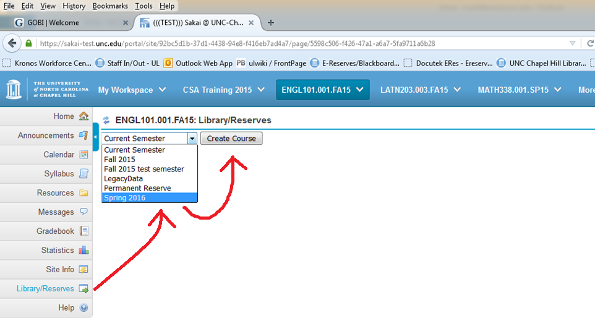

You will see one of the screens below. The screen on the left is the one you want. If you get the one on the right, click on the words “Switch to Instructor Mode.”

Next, click on “Add Reserve Items,” as shown below.

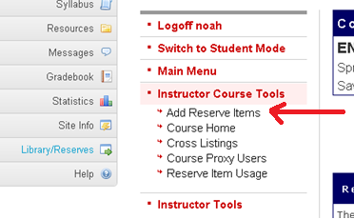

The next page will display a list of item types you can place on reserve.
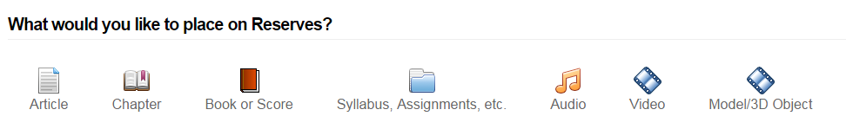
Select the type of item you would like to place on reserve.
The form for inputting citation information will differ slightly based on which item type you select. A screenshot of the form for articles is shown on the next page.

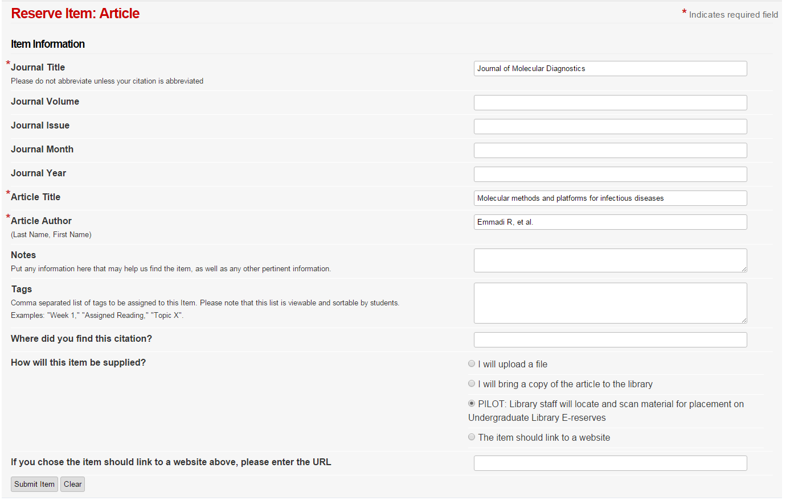

Only the fields with red asterisks are required, although it is helpful if you can fill in as much citation information about the item as possible.

You have a number of options for how the item will be supplied, from uploading it yourself, bringing a copy to the library, linking to a website with the article, or having library staff locate and scan the material.
NOTE: For the PILOT option, “Undergraduate Library E-reserves” refers to all E-reserves for College of Arts & Sciences classes, as well as most of the graduate schools. This summer, the Health Sciences Library will also pilot the pull and scan service for Health Affairs classes (Medicine, Dentistry, Public Health, etc.) so this option wording will change at that time.

After filling out the form and clicking the submit item button, you will be taken to a page that shows a list of all the reserve items that have been submitted for the course, and the status of those items. Here is a screenshot of the status of the above article:
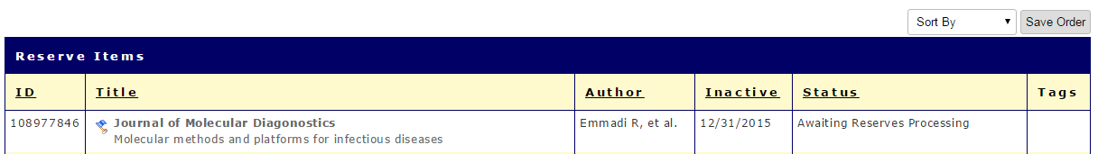

This item’s status is currently “Awaiting Reserves Processing,” because we selected the option to have library staff locate and scan the item. When the material is scanned and uploaded the status will change to “Item Available on Electronic Reserves.”

Please note that any materials that you upload to E-reserves will be available immediately.

Here is another example of a form for placing items on reserve, this time for books or musical scores:

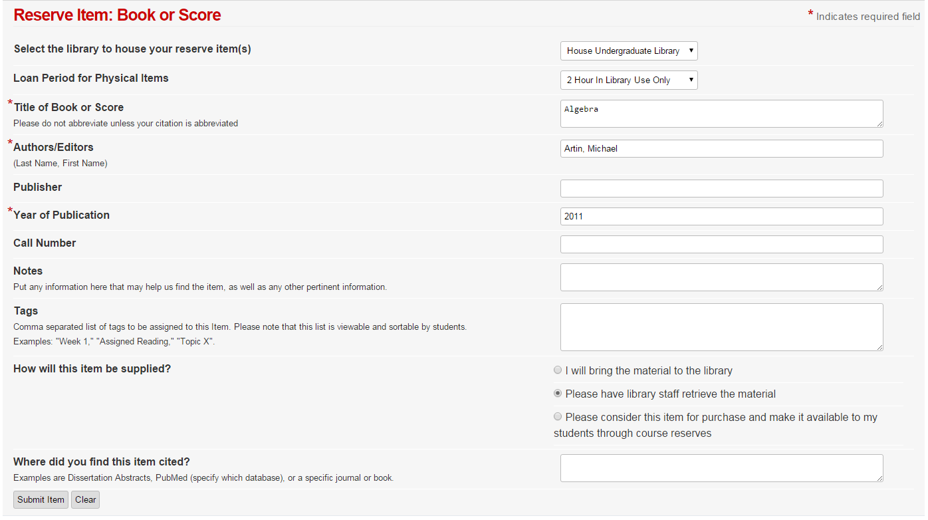
Once the book has been retrieved and processed by library staff, the item’s status will change to “Item Available at Reserve Desk,” as shown in the image below:

